

DEPARTMENT OF B.E ELECTRONICS ENGINEERING
(VLSI DESIGN AND TECHNOLOGY)

EMBEDDED SYSTEMS AND IoT DESIGN

MINI PROJECT REPORT

DESIGN AND DEVELOPMENT OF AIR MOUSE USING EMBEDDED & IOT TECHNOLOGY

TEAM NAME: swipe squad.

TEAM MEMBERS:
Dharshini.K- 2117230050010

Jayashree.G- 2117230050020

DESIGN AND DEVELOPMENT OF AIR MOUSE USING EMBEDDED & IOT TECHNOLOGY

Abstract:

This project implements an embedded Air Mouse system that allows a user to control a computer cursor using hand gestures. The system is built using an MPU6050 accelerometer and gyroscope sensor, an Arduino/ESP32 microcontroller, and a Bluetooth module. The MPU6050 detects the tilt and orientation of the hand, which is processed by the microcontroller to calculate cursor movement. The data is transmitted wirelessly to a PC, where it acts as a mouse input. This project reduces the need for a traditional mouse and provides a more natural, gesture-based interface for human-computer interaction

Components Required:

SSNO | COMPONENTS | Quantity | DESCRIPTION
1. | ESP32 Dev Board | 1 | Microcontroller board used as the brain of the project
2.2 | MPU6050 (Accelerometer + Gyroscope) | 1 | Detects tilt, orientation, and motion for controlling mouse cursor movements.
3. | Push Buttons | 2 | Used for left-click and right-click mouse functions.
4.4 | Jumper Wires | As required | For making electrical connections between components.
5.5 | Power Supply (USB CABLE) | 1 | Provides power to the microcontroller and modules.
6.6 | Breadboard | 1 | To fix and arrange the circuit
7.7 | Laptop / PC with Bluetooth Support | 1 | Acts as the output device where mouse control is performed.

Working Methodology:

- SensingMovement:The MPU6050 sensor continuously measures the hand’s tilt, orientation, and motion in real time.
- Data Processing:The ESP32 microcontroller receives the sensor data and maps it into corresponding cursor movements along the X and Y axes.
- Wireless Transmission:Processed data is transmitted via Bluetooth from the ESP32 to the paired computer.
- Cursor Control:The computer interprets the incoming data as mouse movements, enabling smooth control of the on-screen cursor.
- Clicking Functions:Push buttons connected to the system are assigned for left-click and rightclick operations, ensuring complete mouse functionality.
Thus, by tilting or moving the hand, the user can control the cursor’s movement, while button presses perform the required click actions.

Block Diagram:

MPU6050 Sensor → Microcontroller (Arduino/ESP32) → Bluetooth Transmission → Computer (Mouse Control)

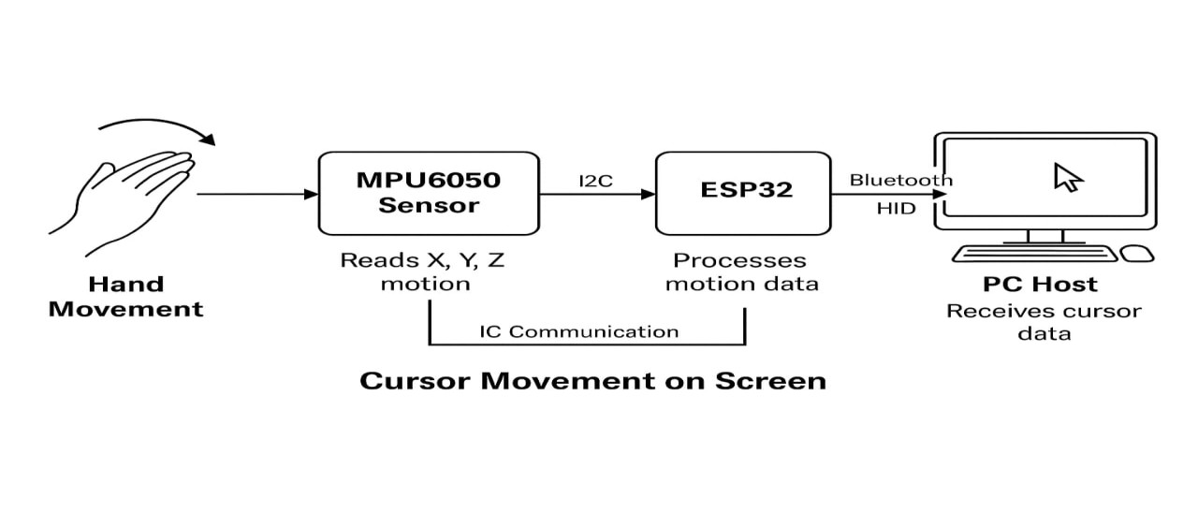
Circuit Diagram:
Connections:
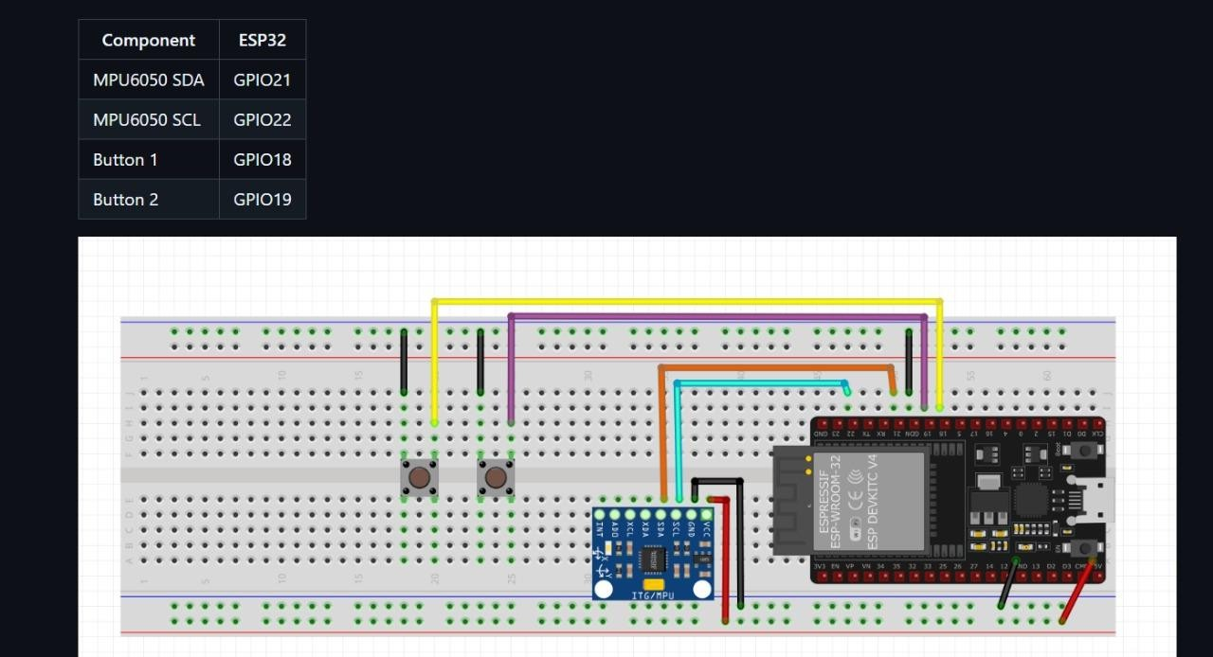

- POWER SUPPLY:

MPU6050 VCC → ESP32 3.3V
MPU6050 GND → ESP32 GND
- I²C CONNECTIONS:
MPU6050 SCL → ESP32 GPIO 22 MPU6050 SDA → ESP32 GPIO 21 • BUTTONS:
Left Button → ESP32 GPIO 19 + GND
Right Button → ESP32 GPIO 18 + GND

Steps to Implement the Project:

Step 1: Connect MPU6050 sensor to ESP32 via I2C communication • MPU6050 Pins:
  - VCC → 3.3V on ESP32 (don’t use 5V, it can damage the sensor).
  - GND → GND on ESP32. o SCL → GPIO22 (ESP32 default I2C clock).
  - SDA → GPIO21 (ESP32 default I2C data).
- Double-check wire placement to avoid loose connections.
- The MPU6050 will send acceleration + gyroscope data to ESP32 via I2C.

Step 2: Connect ESP32 to the PC with Bluetooth
- Power the ESP32 via USB cable to your laptop/PC.
- ESP32 has inbuilt Bluetooth, so no extra module needed.
- Later in code, we will configure ESP32 as a Bluetooth HID (Human Interface Device) → so the PC sees it as a mouse.
- On PC, open Bluetooth Settings → Add Device → Pair ESP32 (device name will appear from your code).

Step 3: Connect push buttons to digital pins for left and right clicks • Take two push buttons:
  - Button 1 = Left Click o Button 2 = Right Click
Wiring:
  - One side of each button → GND.
  - Other side of Button 1 → e.g., GPIO18.
  - Other side of Button 2 → e.g., GPIO19.
- In code, we’ll configure these pins as INPUT_PULLUP (so button press is detected when the pin goes LOW).

Step 4: Write ESP32 code to read sensor values and map them to cursor movements • Install Arduino IDE and add ESP32 board support.
- Required Libraries:
  - Wire.h (for I2C).
  - MPU6050.h or Adafruit MPU6050.h (to read motion data).

  - BleMouse.h (to send Bluetooth mouse signals).
- Code flow:
- Initialize MPU6050 & BLE mouse.
- Continuously read acceleration/gyro values.
- Map tilt angles to X-Y cursor movement.
- Check button presses and send mouse click commands.

Step 5: Pair the Bluetooth device with the computer
  - Once code is uploaded, ESP32 will start advertising as a Bluetooth mouse.
  - On PC:
    - Go to Settings → Bluetooth → Add Device.
    - Select ESP32 device (name will be shown as per code).
    - Once paired, PC will treat ESP32 as a normal mouse.

Step 6: Upload the code and test cursor movement based on hand gestures
  - Upload code using Arduino IDE → select Board = ESP32 Dev Module and correct COM port.
  - Move the breadboard/ESP32 with MPU6050 in your hand → cursor should move on screen.
  - Press buttons → should perform left/right click.

Step 7: Debug and calibrate sensitivity for smooth control • If cursor is moving too fast or jittery:
    - Adjust scaling factor in code (e.g., divide raw sensor values by a higher number).
    - Use a threshold to ignore very small motions (to reduce shaking).
  - Test different tilt angles until movement feels smooth.
  - Debug button wiring if clicks don’t work (check pull-up logic).

Output Photos with Description:

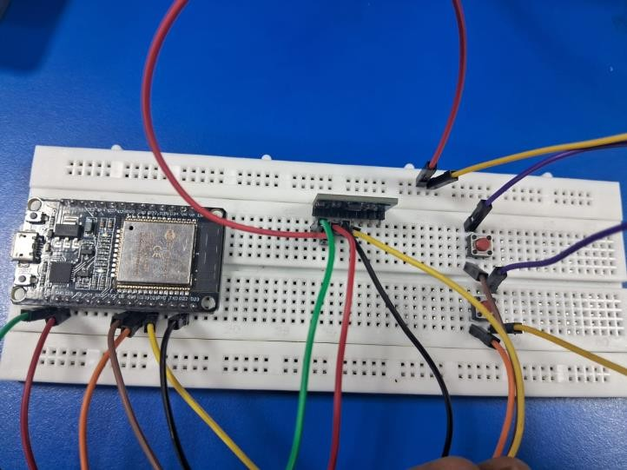
Image 1
The connections given using jumper wires fixed in breadboard according to steps.
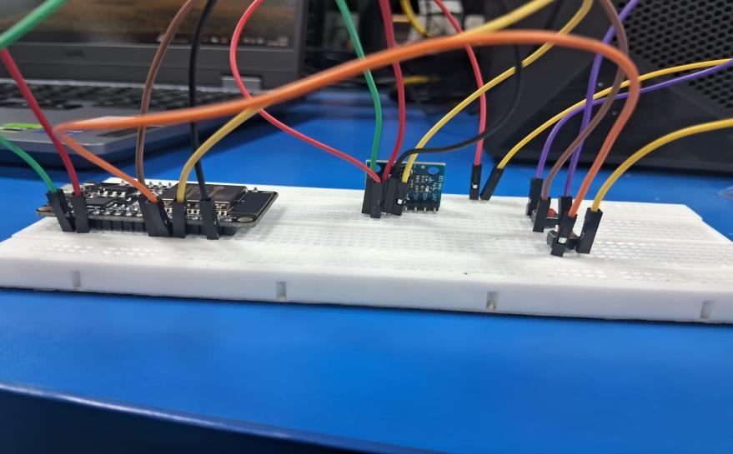
Image 2
Image 2:The image shows the ESP32 connected with the MPU6050 sensor and push buttons on a breadboard, demonstrating the hardware setup for real-time testing.

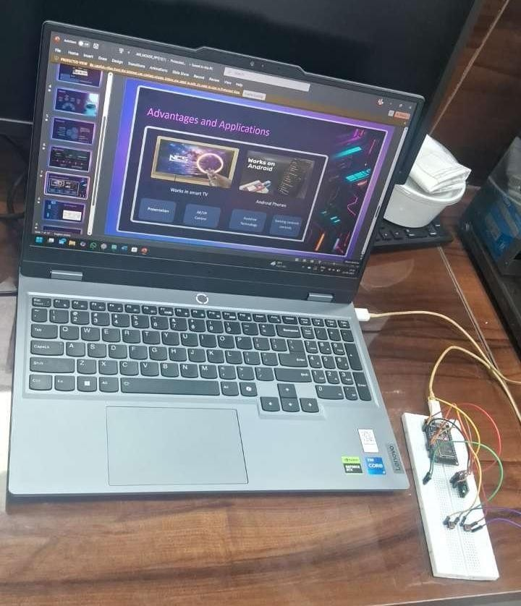
Image 3
Image 3: The whole setup of airmouse .
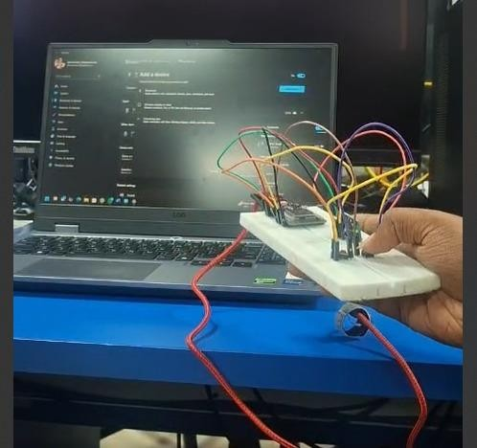
Image 4
Image 4: The complete prototype of the air-mouse system, with ESP32 and MPU6050 connected on a
breadboard, interfaced with the laptop for testing and cursor control

Future Scope:

Voice Command Integration: Enhance usability by combining motion control with voice-based inputs for hybrid interaction.
Advanced Gesture Recognition: Incorporate algorithms to identify complex gestures (e.g., swipe, circular motion) for intuitive control.
Wearable Implementation: Develop a glove-based or compact wearable design for improved comfort and portability.
Extended Applications: Adapt the system for immersive use in gaming, augmented reality, and virtual reality environments.

Conclusion:
The Embedded Air Mouse project successfully demonstrates a practical implementation of gesturebased human–computer interaction. By utilizing the MPU6050 sensor in combination with Bluetooth connectivity, the system enables seamless cursor control and click functionalities. This work highlights the potential of embedded systems as alternatives to conventional input devices and opens avenues for applications in virtual reality, augmented reality, and assistive technologies.”

Program Code:

#include <Wire.h>
#include <Adafruit_MPU6050.h>
#include <Adafruit_Sensor.h>
#include <BleMouse.h>
#define LEFTBUTTON 19
#define RIGHTBUTTON 18
#define SPEED 10 // Pointer speed multiplier
Adafruit_MPU6050 mpu; BleMouse bleMouse; void setup() { Serial.begin(115200); pinMode(LEFTBUTTON, INPUT_PULLUP);
pinMode(RIGHTBUTTON, INPUT_PULLUP);
if (!mpu.begin()) {
Serial.println("Failed to find MPU6050 chip!");
while (1) { delay(10); }
}
Serial.println("MPU6050 Found!"); mpu.setAccelerometerRange(MPU6050_RANGE_2_G); mpu.setGyroRange(MPU6050_RANGE_250_DEG); mpu.setFilterBandwidth(MPU6050_BAND_5_HZ);
bleMouse.begin();

delay(2000); // Wait for BLE to connect
}
void loop() { if (bleMouse.isConnected()) { sensors_event_t a, g, temp;
mpu.getEvent(&a, &g, &temp);

// Use gyroscope data for movement int dx = (int)(g.gyro.y * SPEED); // Rotate wrist left/right → X movement int dy = (int)(-g.gyro.x * SPEED); // Rotate wrist up/down → Y movement

bleMouse.move(dx, dy);

// Left click
if (digitalRead(LEFTBUTTON) == LOW) { if (!bleMouse.isPressed(MOUSE_LEFT)) {
bleMouse.press(MOUSE_LEFT);
}
} else {
if (bleMouse.isPressed(MOUSE_LEFT)) {
bleMouse.release(MOUSE_LEFT);
}
}
// Right click
if (digitalRead(RIGHTBUTTON) == LOW) { if (!bleMouse.isPressed(MOUSE_RIGHT)) { bleMouse.press(MOUSE_RIGHT);
}
} else {
if (bleMouse.isPressed(MOUSE_RIGHT)) { bleMouse.release(MOUSE_RIGHT);
}
}
}

